A RAM-NATH GROUP COMPANY · SERVING INDUSTRY SINCE 1943

NORTH AMERICAN OPERATIONS
Maple MPSS
Maple MPSS is the North American arm of the Ram-Nath Group. Founded in Chennai in 1943, the group has spent eight decades building trusted relationships across the chemicals, polymers and packaging industries. Maple MPSS carries that standard into Canada — giving North American manufacturers the reach of a global operation with the accountability of a supplier in their own time zone.
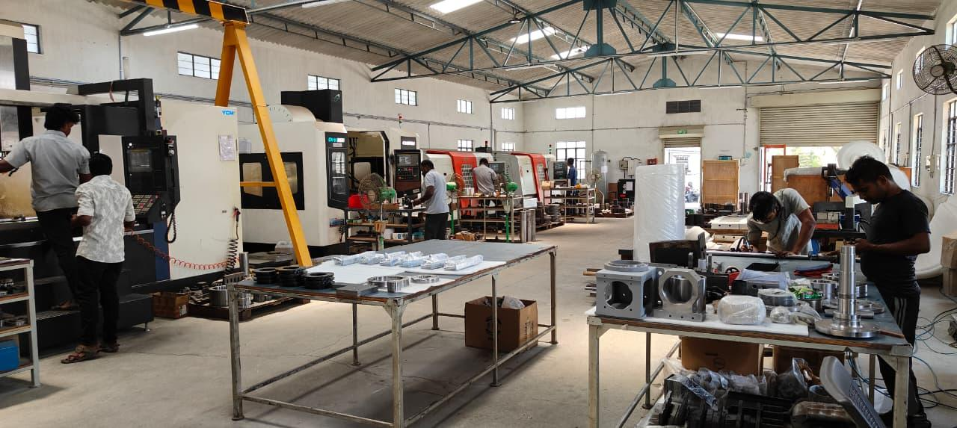
Fig. 1 — The group’s machining floor, Chennai.
Eight decades of trust, extended to North America
Since 1943, Ram-Nath & Co. has grown from a single agency into an established Chennai industrial group serving the chemicals, polymers, additives and packaging sectors, alongside its companies Odo-Rite, LiveRight and NRight. The group’s reputation was built on a simple idea: deliver trust, not just product.
Maple MPSS applies that same principle to a different need. From manufacturing operations in India and a Canadian presence in Burlington, Ontario, it brings manufacturing sourcing and applied AI to North American manufacturers — particularly the packaging and industrial firms the group has served for generations. Every engagement is run by a Canadian project lead, so clients gain the scale of the group with a single point of accountability close to home.
Two services. One operating team.
Sourcing Services
Custom machined parts, CAD and design-for-manufacturing, and overflow capacity when a client’s own shop is over its limit. Built for packaging OEMs, system integrators and general industrial sourcing across North America.
- Custom machined parts to drawing or specification
- CAD and design-for-manufacturing support
- Overflow and surge production capacity
AI Services
Custom CRM deployments, workflow automation and supply chain optimisation. Each engagement starts with a one-week operations audit to find the bottleneck, then builds the software that removes it.
- Custom CRM deployment and configuration
- Workflow and document automation
- Supply chain and reporting optimisation

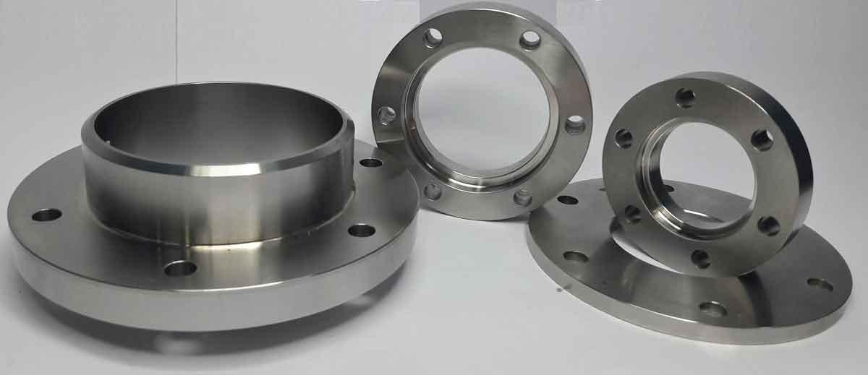
Fig. 2 — Finished precision components, machined to specification.
The power of an offshore operation, without the offshore setup
Engineering and manufacturing are delivered through operations in Indi; the client relationship runs from Canada. A client sends a drawing or describes a bottleneck, and a Canadian project manager owns the outcome — quoting, communication, revisions and delivery. There is no overseas relationship to manage, and one person is accountable from the first conversation to delivered work.
Who you work with
Prrithive Sridharan · Co-founder, Business Development
Leads client relationships, engagement planning and day-to-day operations across the North American market.
Mr. Srinivasan K .A · Director, Strategy
Strategic oversight, customer relationships and supplier negotiations, with approvals on large quotes. The senior face of Maple MPSS in buyer conversations.
Mr. Hari Narayanan V · Director, Operations
Operations leadership, capacity planning and delivery accountability, with technical review of complex jobs. The senior point of contact for engineering teams.
Send a drawing. Or describe the bottleneck.
Maple MPSS works with Canadian manufacturers first, and across North America from there. A concrete part or a concrete problem is the fastest start — no sales call required.
Website maplempss.com
Email info@maplempss.com
Phone +1 647-671-4516

Maple MPSS — North American operations of the Ram-Nath Group · Burlington, ON · Chennai, TN

